MATH 1350 Lab 1 – Descriptive Statistics

Much of the data we’ll be using in class is from the Triola data sets. The descriptions are in appendix B of your text. This lab uses Data set 7, IQ and Lead.

This lab will use the data in the IQLead.xls file. Start out by finding the file “IQLEAD.xls” in the module for chapter 1 in Canvas. Then:Click on the file name and then.

1. Click on the download option.
2. The following dialog box should come up (see below). Click on OK to open the file.

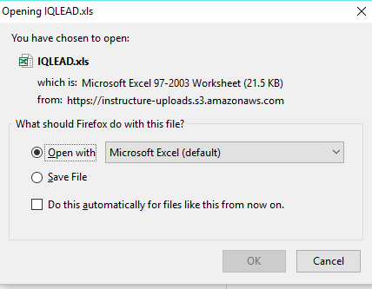

**Descriptive Statistics:**

1. Using Excel functions
   1. Enter the following labels in cell J1 to J8



* 1. For the data in column IQV (F2:F122), enter the formulas for Count, Min, Max, Range, Mean (Average), and Standard Deviation (treat as sample data).

1. Using StatCrunch
   1. Log into StatCrunch.com
   2. Click on the Open StatCrunch tab
   3. Copy cells A1 to H122 from the Excel file, by highlighting those cells, then use CTRL C to copy them
   4. In StatCrunch put your curser on cell **VAR1** and use CTRL V to paste the data from the Excel file to the StatCrunch file.
   5. Select the following menu items: Stat->Summary Stats->Columns
   6. In the Input Box
      1. Select Column(s): IQ Verb
      2. Where: --optional—
      3. Group by: --optional—
      4. Statistics: n, mean, std. dev, std err, median, range, min, max, Q1, Q3 ( To select, hold down CTRL while you click on the choices )
   7. Press the “Compute” button
   8. Copy the output and paste it onto J10 of your Excel file. To do this click on the chart, then Ctrl + a, to select everything, then CTRL C to copy it, then go to Excel J20, use Ctrl + V to paste it.

* Based on the material covered in class, what statistics are useful?
* Write a short paragraph describing the results that are useful.

3)Histograms with StatCrunch:

1. Choose the following menu options Graph->Histogram
2. In the input Box:
   1. Select Column(s): IQV
   2. Where: --optional—
   3. Group by: --optional—
   4. Type: Frequency
3. Press the “Compute” button
4. Copy the output and paste it onto the Excel file. Rt click on the chart, choose copy, go to Excel, Ctrl + Alt + V.

* Describe the distribution. Is it normal, skewed, bimodal?

4) Pie and Bar Charts with Excel using Pivot Tables

* 1. Highlight A1 to C122 ( these cells should only contain data).
  2. Select menu options: Insert->Pivot Table
  3. Click on the option to Place the table in the “Existing Worksheet”
  4. Enter the “Location” J68
  5. You will get a “Field List” dialog box. In the box:
     1. Place Sex in the Row Labels by dragging and dropping it.
     2. Lead in the Values
     3. Rt click on the pivot table on Count of Lead, which will open a box, choose “Value Field Settings”
     4. Select Count
  6. While the Pivot Table is highlighted, use the following Menu options: Insert->Pie->2-D Pie
  7. Click on the pie chart
  8. Right Click and add Data Labels
  9. Right Click and Format Data Labels (click on the Percentage box to add the % for each category)
  10. Highlight the Pivot Table, Insert -> bar chart icon -> 2 – d barchart.
* Is there an advantage to the Pie Chart over the Bar Chart? Explain?

**Save your Excel sheet with the answers to the question and submit it through Canvas.**